Rotary Club of Kathmandu Mid-Town
Breakfast Chatter




21 September 2012 The Weekly Bulletin of Rotary Club of Kathmandu Mid-Town Bc-21.9/012-13

District : 3292 Web: www.rotarymidtown.org.np Club Id : 26776

SEPTEMBER IS THE NEW GENERATIONS MONTH
Reaching out to New Generations is a commitment to the future of your Rotary club. Clubs that build ties with youth in their communities cultivate future members and become rejuvenated by the energy and new perspectives that young people have to offer. Share Rotary’s ideal of service through vocational and community service projects that target youth, such as career days and mentoring programs.

Friday, 6 July: First meeting of the Rotary Year 2012-13:

23rd Installation Ceremony of the Club
Club’s new management team headed by President Devendra Nath Gongal was installed. DG Yogendra rang the bell to declare closing of Rotary year 2011-12 and beginning of Rotary year 2012-13. DG presented the Presidential collar to Rtn Devendra Gongal declaring him the President of the Club for 2012-13. Charter President Dr. Roop handed over the Charter of the Club, hammer and gavel to incoming President Devendra. Outgoing President Som pinned the President`s pin to incoming President Devendra.
President Som thanked the members of the Club for extending cooperation during the year of his tenure. It was a privilege to serve the community, he said. The Club was awarded the first prize under Community Service Avenue. The members of the Club contributed US$ 5,000+ during the year to the Rotary Foundation. Several members of the Club served as leaders in the district level. The Club recorded 96% retention and 6% addition in membership status.
President Som presented a token of love to the Chief Guest DG Yogendra. He presented plaques to the members of his Board in appreciation of their cooperation during the year.
President Devendra expressed gratitude to the Club members for entrusting him the responsibility to lead the Club during the year Peace through Service. He humbly accepted the role and requested all the members to extend him cooperation to make the year a success and achieve the goal set by DG to add three members in each club and contributing to the Rotary Foundation.
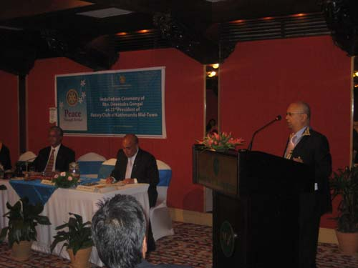
President Devendra introduced his Board and pinned them individually
The Board comprises of :
Rtn Devendra Nath Gongal President
Rtn Dr Som P Pudasaini Immediate Past President
Rtn Saroj Shrestha President Elect
Rtn Govinda Chipalu Vice President
Rtn Laisram Buddha Singh Secretary
Rtn Jo Logghe Treasurer
PP Dr Chandra Lekha Tuladhar Chairperson, New Generations
PP Ajaya Sthapit Chairperson, Service Projects
Rtn Paras Chairperson, Club Administration
Rtn Dr Isabella Khadka Chairperson, Membership Development
Rtn Rabi Karmacharya Chairperson, the Rotary Foundation
Rtn Lisa Choegyal Chairperson, Public Relations
PP Komal Chitracar Sergeant-at-Arms
Rtn Pramod Poudel Joint Secretary
DG Yogendra thanked the members of the Club for their affection and support. He extended special thanks to PP Niranjan, PP Gopal, PP Mani and PP William. He appealed the members for their support and cooperation to make his tenure a resounding success and meet the District goals.
President Devendra proposed toast for Peace and Prosperity of the People of Nepal and the Good Health of President Ram Baran Yadav. IPP Som proposed toast for the Promotion of Worldwide Peace and Goodwill through Rotary International.
President Devendra presented on behalf of all the members of the Club a plaque as a token of love to IPP Som for the laudable leadership that he provided during 2011-12 to the Club.
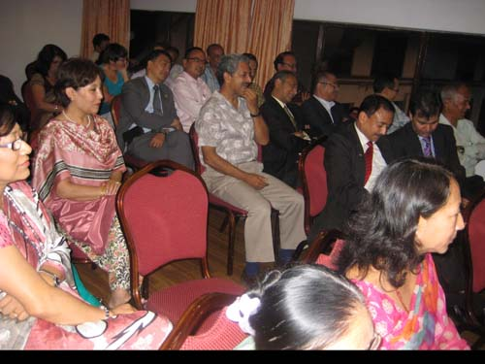

Friday, 13 July:
Guest Speaker Dr. Deepak Bajracharya used the platform to present his post retiral plan dilemma. A lively discussion ensued during which many members enumerated various avenues that were open for him to explore.
A contribution of Rs.10,000 to be made by the club towards the Ring Road Signage Improvement Project jointly sponsored by 9 other Rotary Clubs under the aegis of the Traffic Police.

Friday, 20 July:
In-House Speaker, PP Pratap made an elaborate presentation with his atypical passion and eloquence on the “Mission Impossible” Project of rehabilitating the Bishnumati river and sought the Club’s participation in the Project. Given the intractable nature of the subject, there were a lot of informed comments from various members which PP Pratap and his group took on board for consideration.
DG Yogendra Pradhan, given the scale of the Project, recommended that PP Pratap and the Project team involved should make this presentation to the District Council to examine if a Rotary Distrcit level intervention could be made.

Friday, 27 July: (Dinner meeting)
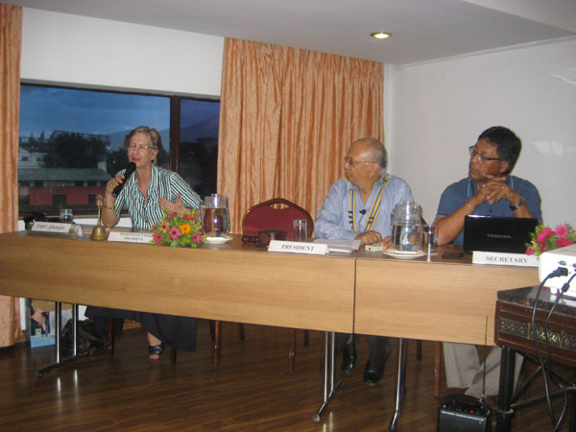
Guest/In-House Speaker: After the regular club meeting basics President Devendra invited club member HE Rtn. Verena, who is leaving Nepal soon, to share her experiences in Nepal to club members on the occasion. Rtn Verena spoke at length broadly on 2 aspects of her experiences in Nepal – one aspect being a critical insight, both through her well informed talk as well as response to questions from the floor post her talk, into the social, political and legal challenges the diplomatic community and the country’s leaders overcame in arriving at the conclusion of the Peace and the continuing Constitution framing processes.
The second aspect she spoke about was of her personal appreciation of the genuine warmth of the people of Nepal encountered on many of her personal and official visits to many places in the country. She also appreciated the rich cultural heritage and the beautiful landscape Nepal offers to persons like her who enjoy trekking. HE wishes the people of Nepal well and hopes they would find an amicable solution to its socio-political issues.

Friday, 3 August:
The first Club Assembly of the Year.
After completing the regular meeting basics President Devendra handed over the meeting to AG Dr Jeeval Lal Amatya for conducting the club assembly. The chair-persons of various committees provided activities progress review and reporting in the Club assembly.

Friday, 10 August:
Guest speaker Rtn Badan Nyachhyon, PP, RC Mount Everest, an experienced engineer, who has been very actively engaged in his clarion call for zero waste, spoke about the importance of a clean environment in the urban atmosphere by making the local communities adopt zero waste management of solid waste. “It is but the mental attitude that has to be changed, the action itself is so simple to follow.”
Information was provided in the meeting that RI District 3292 District Membership Seminar was scheduled to be held on Saturday,18 August 2012, venue: Hotel Radisson. Club members were urged to participate in the seminar as it would benefit both new as well as old members – basics for the new and refresher to the old.

Friday, 17 August:
A large contingent of fire fighting team from Autonomous Province of Bolzano/Bozen (inlcuding a visiting Rotarian), arriving Kathmandu to hand over their City’s gift of fire fighting equipment to Kathmandu Metropolitan City, attended the club meeting. President Devendra greeted them with warm welcome to the meeting. Before presentation, each of the team members provided brief personal introduction. Commander of the Bolzano/Bozen Fire Brigade, Mr. Ernst Preyer expressed his team and City’s happiness in being able to help fortify KMC’s ability to fight fire disasters through their donation of the fire fighting vehicles and equipment which were ideally suited for Kathmandu City’s urban layout. He also thanked the Club for continued support in anchoring the entire process of liaison between the cities of Bolzano/Bozen and Kathmandu.
The meeting was informed that the fire fight equipment and vehicles from Bolzano City were being formally handed over to KMC on 19 August 2012.

Friday, 24 August:
In-house speaker PP CK Golchha gave an interesting presentation on the biggest 3H Grant project in Nepal – Reproductive Health and Micro-credit in Nepal: ANM Maxi Project.
The project with the objectives of getting 52 girls from remote areas, providing them ANM training for 18 months, helping them establish 52 clinics and also helping them channel funds through micro-credit in remote areas of 10 district of western Nepal – Manang, Mustang, Salyan, Dolpa, Kalikot, Mugu, Jumla, Humla, Bajura and Baitadi, started its activities in September 2007 and is scheduled to end in August 2014.
The project, financed under the 3H Grant of the Rotary Foundation, is partnered by Rotary Club of Darmstadt Bergstrasse, Germany and Rotary Club of Kathmandu Mid-Town, and is also supported by UNFPA and NSI for SBA training. In addition, numerous local agencies and organizations did provide support and help in varied fields.
President Devendra informed that the fire fighting vehicles and equipment from Autonomous Province of Bolzano/Bozen, Italy were handed over to the authority of the KMC on 19 August as scheduled in a special program, graced by Dy Prime Minister Narayan Kaji Shrestha. President Devendra thanked all those who contributed one way or other in this very important project, and acknowledged particularly the contribution provided by Rtn Navyo Eller.
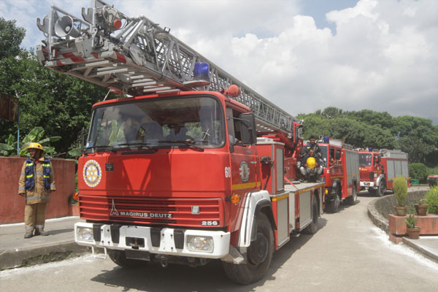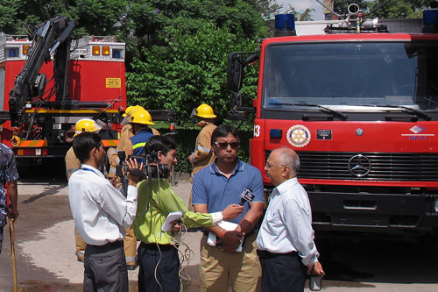

Friday, 31 August: Second Club Assembly
President Devendra, after completing the regular basics of the meeting, requested AG Dr. Jeevan Lal Amatya to conduct the second Club Assembly. AG Dr Amatya thanked the president and asked the committee chairpersons to present progress reviews of the projects/activities and future plans in their respective venue. In response to the AG’s request, chairpersons of the committees presented their plans, programs, and activities in their respective venues.
AG Jeevan Lal noted the contribution made by RC Kathmandu Midtown enhancing the stature of RI District 3292 through the efforts put in to facilitate the gifting and handing over of the fire fighting vehicles and equipment by the Autonomous Province of Bolzano/Bozen to the KMC.
AG Jeevan Lal also announced the tentative schedule of 19th November of the RI President’s visit to District 3292. He also announced that those members contributing to TRF before end of September 2012 will receive their recognition personally from the RI President.
Rtn. Rabi shared his impressions of the interface with 2 ANMs (who were a part of the club’s 3H Grant project) encountered during the course of his trekking and surfaced their need for basic child delivery equipment. Rtn. KNS Thapa donated a sum of Rs.10,000/- to the club to be specifically used for purchase of and providing ANMs child delivery equipment. President Devendra acknowledged and thanked Rtn KNS for the donation.

Friday, 7 September:
September is the month of New Generations. And in line with the spirit of new generation the very first meeting of the month September, the Rotaract Club of Kathmandu Mid-Town was invited to present their activities, programs and projects. Rtr Kishore Acharya, President of Rotaract Club provided a succinct presentation on club activities and programs hitherto and incoming projects for the year - vision screening and prosthetic arm project.

Friday, 14 September:
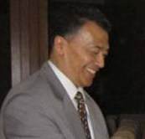
No guest speaker! Charter President Dr Roop Jyoti, on special request of
President Devendra, agreed to talk on the benefits of Vipassana. For CP Roop
there is no need of any preparation for talking on the subject since he
himself is a Vipassana Guru. He explained eloquently what Vipassana is,
how it helps people in having positive thinking, in tackling situations, keep
mind peaceful and thus improve living. The technique of Vipassana is a simple,
practical way to achieve real peace of mind and to lead a happy and useful life.
Vipassana means to see things as they really are – a logical process of mental
purification through self observation.
If you want to develop your capability to control your uncontrolled mind in order to live peaceful, take Vipassana course and practice Vipassana. It teaches you art of peaceful living.

Weekly Meetings and Programs :
Date | Program/Speaker | Program/Topics of Presentation
21 Sep 2012 | Binod Shahi | Educating children in Upper Dolpo
28 Sep 2012 | ?? | ??

On Friday, 21 September:
Binod Shahi, a young Newar from Kathmandu, who is all set for providing schools and education facility in Upper Dolpa, will be talking about the work he has been doing opening schools and educating children in one of the most remote parts of the country in Upper Dolpa. For the past eight years, he has been living under difficult conditions away from all modern amenities with a strong determination to bring education in communities that have been neglected by the system for decades.

Rotary’s Future Destination: Youngistan!
RC PDG Dr. Ulhas Kolhatkar

Dr Ulhas
Though Rotary has many excursions and few permanent projects in the land of ‘Youngistan’
e.g. Boy’s Work (1916), Youth exchange (1927), Interact (1962), Rotaract (1967), RYPEN,
RYLA etc; for the first time, by way of ‘New Generation’ as fifth avenue, Rotary has clearly
indicated its future destination – ‘Youngistan’
Though most of us are well versed with ‘Turkiministan’, ‘Afghanistan’, ‘Kazakistan’ etc; we are really not well acquainted with ‘Youngistan’. Recently I was browsing ‘Infopedia’ on net and came across fact sheet of ‘Youngistan’. I am sharing these facts with you for few simple reasons :
1) Facts are enchanting and they are bound to attract you to ‘Youngistan’.
2) Our whole nation of Rotary is driven by ‘energy’ and youngistan is replete with ‘energy’ and therefore by default our destination has to be ‘Youngistan’!
3) Greek mythology has a story of ‘Jason’ who brought ‘magic potion’ for his father to turn him young and Indian mythology gives us a story of 80 years old sage ‘Chyawan’ who turned into 18 year old youth by consuming Chyawanprash! ‘Youngistan’ is that ‘magic potion’ or ‘chyawanprash’ for Rotary!
Youngistan: facts in brief
Capital Energy
Official language Enthusiasm
Official name United young of world
Head of state Performer
Six Political divisions Action, Implementation, Creativity, Bravery, Entrepreneurship, Intelligence
Area As large as today's world (excluding dying populations)
Elevation Highest: achievers in all fields Lowest: Not yet performed
Population 50% of total world population, at any given time
Chief products Ideas, Innovations, Out of box thinking, courage, future building
National Anthem We are Champions
National Emblem Galloping horse
National Motto Born to win
National holiday No holiday. All days national day
Currency Friendship
History Created by citizens of youngistan everyday by their action so they live in future, not in history.
source: Samanwoya: e-Bulletin of Rotary Coordinator zone 4 & 6A, August 2012
courtsy: PDG Tirtha Man Sakya

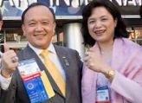
Gary C.K. HUANG of the Rotary Club of Taipei, Taiwan
RI President nominee for the year 2014-15

Since I joined Rotary, I have embraced every new challenge of Rotary service. To me,
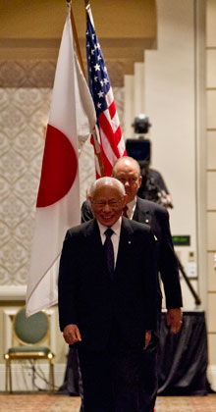
challenge is a very important word. It inspires us. It also helps us to be and to do our best. It allows us to bring out our fullest potential. RI President Sakuji Tanaka

Please send project/activity information, suggestions and photos etc to :
BC Editor: RR Shrestha email: rryesrr@gmail.com

21 Sept 2012 The Weekly Bulletin of Rotary Club of Kathmandu Mid-Town bc-21.9/012-13

